

**Task 1: Science Inquiry – CNS Integration and Discrimination Validation Test**

Weighting 5% of school mark

*NB: Test begins on the next page so that the graphing is easier. ☺*

**Task 1: Science Inquiry – CNS Integration and Discrimination Validation Test**



NAME ____________________________________ **Marks: /40**

**Time allowed: 45 minutes**

A group of students conducted an investigation to test how task complexity affects discrimination time. They timed how long it took each individual to sort cards. Four different tasks were conducted, each increasing in complexity. The first task asked students to start with the pack face down, and turn each card face up, without further sorting. They then calculated the discrimination time required between the simplest task and the more difficult tasks.   
  
Their results are shown in the table below.

**Section 1 Investigation Design and Analysis of Data**

**[20 marks]**

1: State a hypothesis for this investigation. (2 marks)

………………………………………………………………………………………………………………………..

………………………………………………………………………………………………………………………..

2: What was the independent variable? (1 mark)

………………………………………………………………………………………………………………………..

3: State the dependent variable. (1 mark)

………………………………………………………………………………………………………………………..

4: Construct a line graph that plots the average discrimination time for males and females for

tasks B, C and D on the graph paper [round figures to the first decimal point]. (6 marks)

**Results Table: Task time and discrimination time for male and female student as task complexity increases**

|  |  |  |  |  |  |  |  |
| --- | --- | --- | --- | --- | --- | --- | --- |
| **Brain Investigation** | **Task time averages (s)** | | | | **Discrimination time averages (s)** | | |
| **Student name** | Task A | Task B | Task C | Task D | B-A | C-A | D-A |
| Female 1 | 24.9 | 32.8 | 44 | 68.6 | 7.9 | 19.1 | 43.7 |
| Female 2 | 32.7 | 36.7 | 54.7 | 82 | 4 | 22 | 49.3 |
| Female 3 | 31 | 39 | 53 | 82 | 8 | 22 | 51 |
| Female 4 | 28.1 | 35.8 | 48.2 | 72.6 | 7.7 | 20.1 | 44.5 |
| Female 5 | 26.7 | 32.7 | 43.3 | 77.3 | 6 | 16.6 | 50.6 |
| Female 6 | 27.3 | 34.7 | 43 | 63 | 7.4 | 15.7 | 35.7 |
| Female 7 | 31.3 | 36 | 52 | 91 | 4.7 | 20.7 | 59.7 |
| Female 8 | 30.3 | 40 | 51 | 79 | 9.7 | 20.7 | 48.7 |
| Female 9 | 32.7 | 39.7 | 53.3 | 72 | 7 | 20.6 | 39.3 |
| Female 10 | 22 | 29.3 | 40.3 | 60 | 7.3 | 18.3 | 38 |
| Female 11 | 24.3 | 36.7 | 49.3 | 85 | 12.4 | 25 | 60.7 |
| **Female class averages \*** | **28.3** | **35.7636** | **48.3727** | **75.6818** | **7.46364** | **20.0727** | **47.3818** |
| Male 1 | 29.3 | 46 | 60 | 99 | 16.7 | 30.7 | 69.7 |
| Male 2 | 35.3 | 40.3 | 69 | 84 | 5 | 33.7 | 48.7 |
| Male 3 | 30 | 39 | 50 | 65.5 | 9 | 20 | 35.5 |
| Male 4 | 21.3 | 30.7 | 39 | 64.7 | 9.4 | 17.7 | 43.4 |
| Male 5 | 19.3 | 33.7 | 39.7 | 69.3 | 14.4 | 20.4 | 50 |
| Male 6 | 25 | 38.3 | 43 | 59.6 | 13.3 | 18 | 34.6 |
| Male 7 | 20.3 | 31.3 | 41.3 | 57 | 11 | 21 | 36.7 |
| Male 8 | 18.3 | 31 | 37.6 | 47.6 | 12.7 | 19.3 | 29.3 |
| **Male class averages \*** | **24.85** | **36.2875** | **47.45** | **68.3375** | **11.4375** | **22.6** | **43.4875** |

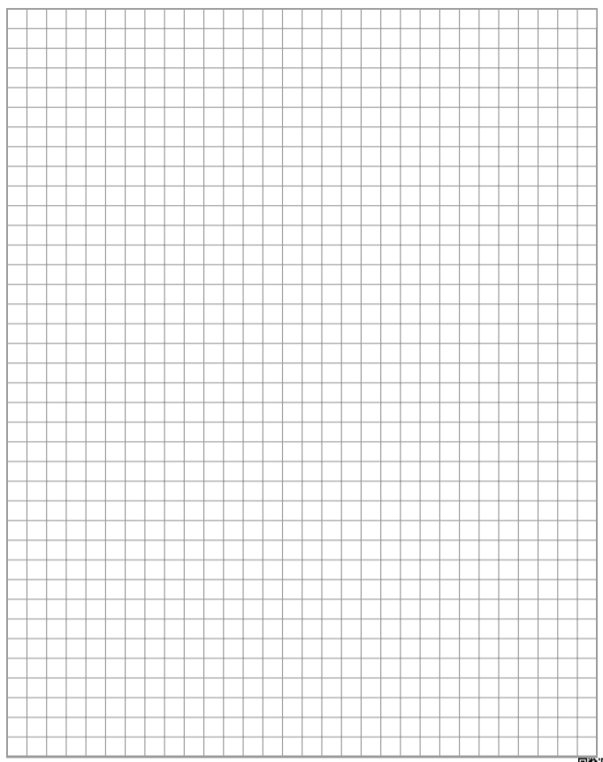

5: Use the table and your graph to answer the following questions:

1. Which gender showed the shortest discrimination time for task D? (1 mark)

………………………………………………………………………….

1. Which gender showed the longest discrimination time for task B? (1 mark)

………………………………………………………………………….

6: Identify the control for this investigation and outline why this is used as the control. (2 marks)

………………………………………………………………………………………………………………………..

………………………………………………………………………………………………………………………..

7:List four other controlled variables. (4 marks)

………………………………………………………………………………………………………………………..

………………………………………………………………………………………………………………………..

………………………………………………………………………………………………………………………..

………………………………………………………………………………………………………………………..

8: Identify the main trend in the data between discrimination time and tasks performed. (2 marks)

………………………………………………………………………………………………………………………..

………………………………………………………………………………………………………………………..

**Section 2: Communicating findings using understandings of Human Biology**

**[20 marks]**

1: Which part of the cerebrum processes and decides on the sequence of actions that need to

be performed in correctly sorting out the cards? (1 mark)

………………………………………………………………………………………………………………………..

2: Which part of the cerebrum integrates and sequences the movements required? (1 mark)

………………………………………………………………………………………………………………………..

3:

Explain why task D took longer than task B. (2 marks)

………………………………………………………………………………………………………………………..

………………………………………………………………………………………………………………………..

………………………………………………………………………………………………………………………..

4: What type of matter in the cerebrum enables saltatory conduction to occur? (1 mark)

………………………………………………………………………………………………………………………..

5: Explain how this brain matter allows saltatory conduction to occur. (4 marks)

………………………………………………………………………………………………………………………..

………………………………………………………………………………………………………………………..

………………………………………………………………………………………………………………………..

………………………………………………………………………………………………………………………..

………………………………………………………………………………………………………………………..

6: John is unable to perform the card playing activity because of muscle tremors. Identify the area of the brain that would cause this problem for John and describe the role it plays in normal functioning.

(3 marks)

………………………………………………………………………………………………………………………..

………………………………………………………………………………………………………………………..

………………………………………………………………………………………………………………………..

………………………………………………………………………………………………………………………..

7: The motor neurons that innervate the muscles of the arms and fingers receive messages from the connector neurons in the brain, which have in turn received messages from sensory neurons. This enables the fingers to clasp and turn over the card to the correct pile.

Explain how the electrical impulse of a sensory neuron is propagated and travels along the sensory neuron to enable this to happen. (8 marks)

………………………………………………………………………………………………………………………..

………………………………………………………………………………………………………………………..

………………………………………………………………………………………………………………………..

………………………………………………………………………………………………………………………..

………………………………………………………………………………………………………………………..

………………………………………………………………………………………………………………………..

………………………………………………………………………………………………………………………..

………………………………………………………………………………………………………………………..

………………………………………………………………………………………………………………………..

………………………………………………………………………………………………………………………..

………………………………………………………………………………………………………………………..

………………………………………………………………………………………………………………………..

………………………………………………………………………………………………………………………..

………………………………………………………………………………………………………………………..

………………………………………………………………………………………………………………………..

………………………………………………………………………………………………………………………..

………………………………………………………………………………………………………………………..

………………………………………………………………………………………………………………………..

………………………………………………………………………………………………………………………..

………………………………………………………………………………………………………………………..

………………………………………………………………………………………………………………………..

………………………………………………………………………………………………………………………..

………………………………………………………………………………………………………………………..

………………………………………………………………………………………………………………………..